SAN DIEGO CONTINUING EDUCATION
EXECUTIVE GOVERNANCE COUNCIL
March 23, 2016 – Cesar E. Chavez Campus
2:00 p.m.
Neill Kovrig Chair

Members Present:

- Carlos Turner Cortez, President, Continuing Education
- Esther Matthew, Acting Vice President, Instruction
- Cynthia Rico, Interim Vice President, Student Services
- Gabe Bakit, Acting Vice President, Administrative Services
- Richard Weinroth, President Academic Senate
- Ingrid Greenberg, Vice President, Academic Senate
- Marie Doerner, Chair of Program Chairs, Academic Senate
- Neill Kovrig, President Classified Senate
- Mary LeDuc, Vice President, Classified Senate

Members Absent:
- Rita Avila, Past President, Classified Senate

Guests: AGC Members, Ranessa Ashton

Approval of Agenda
Agenda approved as submitted without objection

Approval of Minutes
Minutes of March 9, approved MSP/Rico/Matthew

Academic Senate Update
Academic Senate President Richard Weinroth reported on the following:
- The Academic Senate unanimously supported the proposed SDCE Vision and Mission Statement.

Classified Senate Update
Classified Senate Vice President Mary LeDuc reported on the following:
- The Classified Senate unanimously approved the proposed SDCE Vision and Mission Statement.
- Scholarship applications were reviewed and a diversified group of awardees were selected.

Shared Governance Review
Acting Vice President Esther Matthew led a group discussion regarding the following: shared governance committee revisions; reorganizing the shared governance structure; the creation of an administrative organizational structure; the first reading of the Technology Committee and acceptance of an AGC shared governance committee recommendation (SDAERC Committee.)

Recommendation:

To establish the San Diego Adult Education Regional Consortium Committee

In order to implement the San Diego Adult Education Regional Consortium to ensure collaboration and transparency among stakeholders, the establishment of the Ce SCAERC is proposed. The committee will take into consideration the integration between the SDERC plan and other Continuing Education plans including program review, strategic planning and accreditation action plans.

Disposition of Recommendation:

It was moved to accept the establishment of the San Diego Adult Education Regional Consortium (SDAERC) Committee. M/S/P Matthew/Kovrig

Proposed Handbook Review
After much discussion it was proposed that the following committees would fall under the revised shared governance structure:
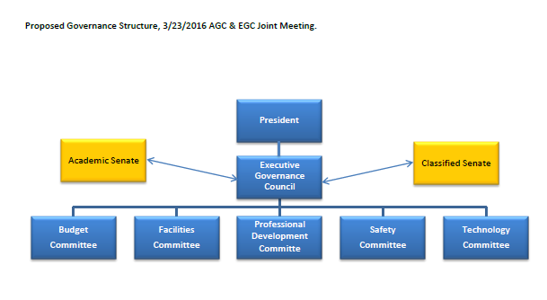
Also, it was proposed that the following committees would fall under a new Administrative/Operation structure:
- Funding Committees/Grants ( note: $100,000 or more must have a committee)
- 231
- Perkins
- BSD
- SDAEBG
- WIOA
- SSSP
- SEP
- CalWorks
- DSPS
- El Civics
- Prop 20
- IELM
- 1010
- Faculty Priority Hiring Committee
- Classified Priority Hiring Committee
- Professional Development
- Deans’ Council
- Student Services Council
- Planning and Institutional Effectiveness (PIE)
- Marketing Committee

It was noted that on each of these committees referenced above has representation from each constituency: administration, academic and classified senates.

Vision Mission and SLO Statements

The following recommendation was brought to EGC from the Administrative Governance Council for consideration:

Recommendation:

San Diego Continuing Education’s Vision, Mission and Student Learning Outcomes (SLOs)

The revised Continuing Education (CE) Vision, Mission and Student Learning Outcomes (SLOs) statements were presented for recommendation to accept.

Disposition of Recommendation:

It was moved to accept the new CE Vison, Mission and SLO statements and forward to the Board of Trustees for approval. M/S/P Matthew/Greenberg

District and CE Strategic Goals and Objectives
Ranessa Ashton provided an update in regard to the Districts and Continuing Education’s strategic goals and objective. The committee is scheduled to meet next on April 25.

WIOA Youth Grant
President Turner Cortez announced that Continuing Education was awarded the WIOA Youth Grant. The grant award is for $2 million + over five years, will serve ex-offenders ages 18-24, out of school youth, unemployed youth with a high school diploma and foster youth. The program will be operated out of ECC and the Cesar E. Chavez campuses with built in staffing of a grant director, counselling and case management staff as well as paid interns. Acceptance of the grant will go before the Board of Trustees in May with a start date of July 1.

Events
The following is a list of upcoming and future events by Month:
- March 24, Board Meeting at Cesar Chavez Campus
- Remaining Spring campus visits: April 4 at North City, April 7 CE Mesa, April 14 at Cesar Chavez
- April Castro Visit
- April 20, Scholarship Awards Event at City College
- April 28, Faculty Appreciation Event at ECC
- April 29 Management Retreat
- May 9-12, Classified Appreciation events at each campus
- May 27, Commencement at Balboa Park
- June 8, 40th Anniversary event at ECC
- June 11, Architect Presentation at Cesar Chavez Campus
- July 16, Pride Parade

Round Table
President Turner Cortez requested a legend for the murals on the Cesar Chavez Car Park

Marie Doerner reported there was support from the program chairs to conduct program review earlier next year. It was requested that the program review cycle be shared with program chairs before the end of the semester in June.

Michelle Fischthal announced the strategic planning meeting met earlier in the week and reviewed the strategic goals.

Esther Matthew reported that she attended Chancellor’s Cabinet for President Turner Cortez and shared that enrollment is a hot topic and looking for CE to increase numbers. She has met with program chairs and deans meeting. It was suggested a letter from the president to faculty be generated.

Meeting adjourned at 4:29 p.m.

