SAN DIEGO CONTINUING EDUCATION
EXECUTIVE GOVERNANCE COUNCIL
And ADMINISTRATIVE GOVERNANCE COUNCIL
June 8, 2016 ECC Room 121
2:00 p.m.
Richard Weinroth Chair

Members Present:

- Carlos Turner Cortez, President, Continuing Education
- Esther Matthew, Acting Vice President, Instruction
- Cynthia Rico, Interim Vice President, Student Services
- Dan Gutowski, Acting Vice President, Administrative Services
- Richard Weinroth, President Academic Senate
- Ingrid Greenberg, Vice President, Academic Senate
- Marie Doerner, Chair of Program Chairs, Academic Senate
- Neill Kovrig, President Classified Senate
- Lorie Crosby Howell, Dean
- Michelle Fischthal, Dean
- Barbara Pongsrikul, Dean
- Leslie Quinones, Dean
- Jane Signaigo-Cox, Dean
- Carol Wilkinson, Dean

Members Absent:
- Rita Avila, Past President, Classified Senate
- Mary LeDuc, Vice President, Classified Senate
- Robin Carvajal, Dean
- Star Rivera-Lacey, Dean

Guests: Ranessa Ashton, Kelly Henwood

Approval of Agenda
Agenda approved as submitted without objection. MSP Kovrig/Matthew

Approval of Minutes
Minutes of May 25, 2015 postponed to next meeting

Academic Senate Update
Academic Senate President Richard Weinroth reported on the following:
- The Academic Senate (AS) reviewed the participatory governance committee descriptions and provided edited documents to Acting Vice President Matthew.
- The AS is requesting to amend the SDCE Strategic Goal number three (3) to add “life-long learning.” the Classified Senate was contacted regarding this change and they have no objection to the additional verbiage. After a brief discussion the following motion was made:

It was moved to accept the Academic Senate’s recommendation have SDCE Strategic Goal number three (3) changed to read “: increase student success, academic achievement, life-long learning and workforce development.” M/S/P Matthew/Greenberg

Classified Senate Update
There was no report.

Review and Approval of Participatory Governance Handbook

Acting Vice President Matthew reported the following two items needed to be discussed with the hope that with this review and input a final will be brought back for acceptance.

Overall Governance Structure Chart was distributed with changes incorporated from the last meeting. President Turner Cortez provided information on the flow and clarification of the participatory governance structure. All recommendations are vetted through the five main committees before the recommendations come to EGC and the President for approval. EGC’s role is to approve or reject items and provide a forum for presentations. If there are issues or questions, the recommendation is returned to the requesting body prior to coming to EGC. President Turner also shared that Continuing Education Board of Trustees Agenda items will be shared at EGC starting in fall prior to being submitted to the District (depending on timeframe to submit). Also, participatory governance training will be scheduled in fall for all employees. At the end of the discussion, the following motion was made:

It was moved to dissolve the Administrative Governance Council and accept the governance structure chart as presented (see below) Item tabled

Item moved to take off the table M/S/P Kovrig/Rico

It was moved to dissolve the Administrative Governance Council and accept the governance structure chart as presented (see below) M/S/P Weinroth/Turner Cortez
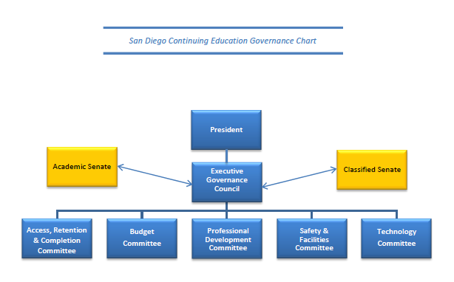

It was moved to require two (2) deans to sit on the five subcommittees reflected in the chart as presented (see above) designate by the Deans’ Council which includes vice presidents. M/S/P Weinroth/Turner Cortez

That part of the participatory governance process will include an assessment of the functioning of participatory governance and that this language is included in the handbook. M/S/P Fischthal/Rico
Events

The remaining committee charters/descriptions that had major edits were distributed for final review and input. The documents have been reviewed by the Academic Senate and their edits are incorporated in the documents presented. The revisions will be approved today, contingent upon Classified Senate approval at their next meeting.

The following is a list of upcoming and future events by Month:

- June 8 40th ECC Anniversary (10:00 a.m. – 2:00 p.m.)
- July Pride Parade (10:00 a.m.)

Roundtable

Meeting adjourned at 3:55 p.m.

